**Exam 2 Instructions**

**OBJECT-ORIENTED PROG**

* This is a take-home exam. You can use any resources that are available for you to finish this exam, except
  + Outsourcing the exam to any person or to any third party websites
  + Copying from other students work
  + Copying direct quotes from the books or internet
* Do not lose your opportunity to learn while working on the exam. Understand the concept and write answers on your own.
* Usually, in life, we have several choices. Unfortunately, you don’t have any choice on this exam. You have to answer all the questions and each part of the problem.
* All the topics on this exam were discussed in class before week 13. So, you cannot claim that the questions are out of the syllabus!
* Refer to Microsoft Word tutorials for proper formatting
* Points will be deducted for grammatical and spelling mistakes
* No two brains think alike unless you are soulmates. Definitely your answers will not be same as other students.
* Read the code of academic integrity before you start the exam. <https://www.nwmissouri.edu/policies/academics/Academic-Integrity.pdf>
* Push your source code to GitHub and provide your GitHub link at the end of the document and in the comment section.
* Don’t use examples that already explained in class or worksheets.
* Provide the input and output screenshots for every program.

**Exam 2 OBJECT-ORIENTED PROG 01FA20 100 pts**

1. (5-Points) (1D-Array - )Write a method that removes the duplicate elements from an array list of integers using the following header:

Public static void removeDuplicate(ArrayList<Integer> list)

Write a test program that prompts the user to enter 10 integers to a list and displays the distinct integers separated by exactly one space. Provide screenshot of executable code with input and output. Here is a sample run:

|  |
| --- |
| Enter ten integers: 34 5 3 5 6 4 33 2 2 4  The distinct integers are 34 5 3 6 4 33 2 |

Answer:

|  |
| --- |
| /*  * To change this license header, choose License Headers in Project Properties.  * To change this template file, choose Tools | Templates  * and open the template in the editor.  */  package Exam02_Q1;  import java.util.Scanner;  import java.util.ArrayList;  import java.util.Collections;  import java.util.List;  /**  *  * @author Saisumithra Jagarlamudi  */  public class Question_1 {  /**  * @param args the command line arguments  */  public static void main(String[] args) {  // TODO code application logic here  Scanner hs = new Scanner(System.in);  ArrayList<Integer> list = new ArrayList<Integer>();  System.out.println("Answer for Question 1: Saisumithra Jagarlamudi\n");  System.out.print("Enter 10 integers: ");  for (int k = 0 ; k < 10 ; k++)  {  list.add(hs.nextInt());  }  removeDuplicate(list);  System.out.print("The distinct integers are ");  for (Integer sh : list)  {  System.out.print(sh + " ");  }  System.out.println();  }  public static void removeDuplicate(ArrayList<Integer> list)  {  List<Integer> indexToRemove = new ArrayList<>();  for (int i = 0; i < list.size() - 1; i++)  {  for (int j = i + 1; j < list.size(); j++)  {  if (!indexToRemove.contains(j) && list.get(i).equals(list.get(j)))  {  indexToRemove.add(j);  }  }  }  Collections.sort(indexToRemove);  for (int i = 0; i < indexToRemove.size(); i++)  {  list.remove(indexToRemove.get(i) - i);  }  }  } |

Output:

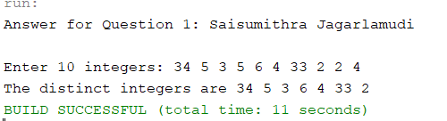

1. (5-Points) (2D- Array) The two-dimensional arrays m1 and m2 are strictly identical if their corresponding elements are equal. Write a method that returns true if m1 and m2 are strictly identical, using the following header:

public static boolean equals(int[][] m1, int[][] m2)

Write a test program that prompts the user to enter two 3 * 3 arrays of integers and displays whether the two are strictly identical. Provide screenshot of executable code with input and output. Here are the sample runs.

|  |
| --- |
| Enter list1: 51 22 25 6 1 4 24 54 6  Enter list2: 51 22 25 6 1 4 24 54 6  The two arrays are strictly identical |

|  |
| --- |
| Enter list1: 51 25 22 6 1 4 24 54 6  Enter list2: 51 22 25 6 1 4 24 54 6  The two arrays are not strictly identical |

Answer:

|  |
| --- |
| /*  * To change this license header, choose License Headers in Project Properties.  * To change this template file, choose Tools | Templates  * and open the template in the editor.  */  package Exam02_Q2;  import java.util.Scanner;  /**  *  * @author Saisumithra Jagarlamudi  */  public class Question_2 {  /**  * @param args the command line arguments  */  public static void main(String[] args) {  // TODO code application logic here  System.out.println("Answer for Question 2: Saisumithra Jagarlamudi\n");  System.out.print("Enter list1: ");  int[][] list1 = getArray();  System.out.print("Enter list2: ");  int[][] list2 = getArray();  System.out.println("The two arrays are" + (equals(list1, list2) ? " " : " not ") + "strictly identical");  }  public static boolean equals(int[][] m1, int[][] m2)  {  for (int i = 0; i < 3; i++)  {  for (int j = 0; j < 3; j++)  {  if (m1[i][j] != m2[i][j])  return false;  }  }  return true;  }    public static int[][] getArray()  {  Scanner hs = new Scanner(System.in);  int[][] m = new int[3][3];  for (int i = 0; i < m.length; i++)  {  for (int j = 0; j < m[i].length; j++)  {  m[i][j] = hs.nextInt();  }  }  return m;  }  } |

Output:

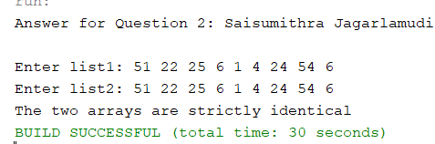

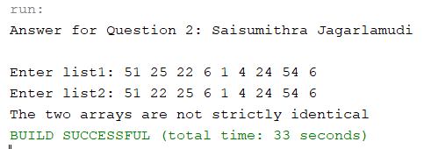

1. (10-Points) (Array List) Write a program that creates an ArrayList and adds a **Loan** object, a **Date** object (Use inbuilt method. No need to create separate class), a string, and a **Circle** object to the list, and use a loop to display all the elements in the list **by** invoking the object’s **toString**() method.

Note: For **Loan** and **Circle** you can use your own attributes and methods. **Constructor** and **tostring()** are mandatory requirements

Answer:

|  |
| --- |
| /*  * To change this license header, choose License Headers in Project Properties.  * To change this template file, choose Tools | Templates  * and open the template in the editor.  */  package Exam02_Q3;  /**  *  * @author Saisumithra Jagarlamudi  */  public class Circle {  private int radius = 5;  private static final double pi=3.14;  public Circle() {  }    public int getRadius() {  return radius;  }  public static double getPi() {  return pi;  }  public Circle(int radius) {  this.radius = radius;    }  public double getArea()  {  return pi*radius*radius;  }  public double getPerimeter()  {  return 2*pi*radius;  }  @Override  public String toString() {    return "Area of Circle: " +getArea() + "\nPerimeter of circle: "+getPerimeter();  }  }  /*  * To change this license header, choose License Headers in Project Properties.  * To change this template file, choose Tools | Templates  * and open the template in the editor.  */  package Exam02_Q3;  import java.util.Date;  /**  *  * @author Saisumithra Jagarlamudi  */  public class Loan {    private int loanAmount;  public Loan(int loanAmount) {  this.loanAmount = loanAmount;  }  public int getLoanAmount() {  return loanAmount;  }  @Override  public String toString() {  return "LoanAmount=" + loanAmount ;  }  }  /*  * To change this license header, choose License Headers in Project Properties.  * To change this template file, choose Tools | Templates  * and open the template in the editor.  */  package Exam02_Q3;  import java.util.ArrayList;  import java.util.Date;  /**  *  * @author Saisumithra Jagarlamudi  */  public class Question_3 {  /**  * @param args the command line arguments  */  public static void main(String[] args) {  // TODO code application logic here  System.out.println("Answer For Question3: Saisumithra Jagarlamudi");  ArrayList<Object> o = new ArrayList<Object>();  Loan loan = new Loan(25000);  Circle circle = new Circle();  Date date = new Date();  String string = new String("New String");  o.add(date);  o.add(string);  o.add(loan);  o.add(circle);  for (int i = 0; i < o.size(); i++)  {  System.out.println((o.get(i)).toString());  }  }  } |

Output:

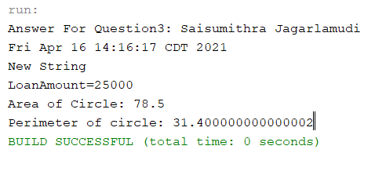

1. (15-Points) What is Inheritance, Polymorphism and Late binding polymorphism? Explain and demonstrate with examples. Provide executable code screenshots for examples.

Answer:

Inheritance: Acquiring the properties of one class to another class. In inheritance we use class, subclass, superclass. There are three types of inheritance single inheritance, multilevel inheritance, hierarchical inheritance.

Explanation:

I have created a super class as Bags and given variables as cost and discount. And a subclass as HandBag for Bags where it extends the super class. And the main method for creating objects for Bags and to print the cost of and bag and to display the cost of bag after discount.

|  |
| --- |
| /*  * To change this license header, choose License Headers in Project Properties.  * To change this template file, choose Tools | Templates  * and open the template in the editor.  */  package Exam02_Q4_I;  /**  *  * @author Saisumithra Jagarlamudi  */  public class Bags {  public int cost = 500;  private double discount = 25;  public Bags() {  }  public int getCost() {  return cost;  }  public double getDiscount() {  return discount;  }  public double getpriceAfterDiscount()  {  return cost - (cost*discount/100);  }    }  /*  * To change this license header, choose License Headers in Project Properties.  * To change this template file, choose Tools | Templates  * and open the template in the editor.  */  package Exam02_Q4_I;  /**  *  * @author Saisumithra Jagarlamudi  */  public class Handbag extends Bags {  public Handbag() {  }  }  /*  * To change this license header, choose License Headers in Project Properties.  * To change this template file, choose Tools | Templates  * and open the template in the editor.  */  package Exam02_Q4_I;  /**  *  * @author Saisumithra Jagarlamudi  */  public class Driver {  /**  * @param args the command line arguments  */  public static void main(String[] args) {  // TODO code application logic here  Handbag h = new Handbag();  System.out.println("Answer for Question4: Saisumithra Jagarlamudi");  System.out.println("Cost of Bag:"+h.cost);  System.out.println("Price After discount: "+h.getpriceAfterDiscount());  }    } |

Output:

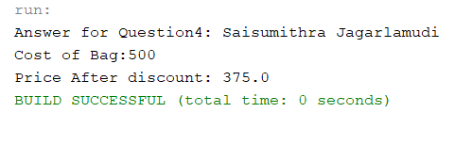

Polymorphism: Polymorphisms means having many forms, the print statement to be displayed in more than one form. There are two types runtime polymorphism and compile time polymorphism.

Explanation: Created a class and methods to initialize the variable inside the methods and displaying the conditions of the statements. And created one more method with variables and displayed the statement. In main method in which we create objects and returned statements by using method name.

|  |
| --- |
| /*  * To change this license header, choose License Headers in Project Properties.  * To change this template file, choose Tools | Templates  * and open the template in the editor.  */  package Exam02_Q4;  /**  *  * @author Saisumithra Jagarlamudi  */  public class Bags {  public static class bags  {  public static void bag()  {  System.out.println("Bag Models");  }  }  public static class TravelBag extends bags  {    public static void bag()  {  System.out.println("TravelBag is a kind of bag");  }  }  public static class BackpackBag extends bags  {    public static void bag()  {  System.out.println("Backpack Bag is a type of bag");  }  }  public static void main(String[] args)  {  System.out.println("Answer for Question4:Saisumithra Jagarlamudi");  bags b1=new bags();  bags b2=new TravelBag();  bags b3=new BackpackBag();  b1.bag();  b2.bag();  b3.bag();  }    } |

Output:

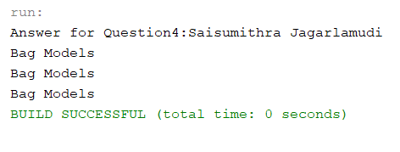

Late Binding Polymorphisms: The compiler does not decide the method to be called. Overriding should be done in polymorphism. In overriding both parent and child have same methods.

Explanation:

Created a class bags and defined methods to print the brandname and year of the bag. In main method created a super class object with subclass objects and returned statements and creating subclass object with super class and returns the brandname, year and isbagavailable.

|  |
| --- |
| /*  * To change this license header, choose License Headers in Project Properties.  * To change this template file, choose Tools | Templates  * and open the template in the editor.  */  package Exam02_Q4.I;  /**  *  * @author Saisumithra Jagarlamudi  */  public class bags {  private String BrandName;  private String year;  public bags(String BrandName, String year) {  this.BrandName = BrandName;  this.year = year;  }  public String getBrandName() {  return BrandName;  }  public String getYear() {  return year;  }  public String toString() {  return "Bags:" + "\nBrandName: " + BrandName + "\nyear: " + year ;  }  public void isAvailable()  {  System.out.println("Bags are available");  }  }  /*  * To change this license header, choose License Headers in Project Properties.  * To change this template file, choose Tools | Templates  * and open the template in the editor.  */  package Exam02_Q4.I;  /**  *  * @author Saisumithra Jagarlamudi  */  public class HandBag extends bags {  private String Availblemall;  public HandBag(String Availblemall, String BrandName, String year) {  super(BrandName, year);  this.Availblemall = Availblemall;  }  public String getAvailblemall() {  return Availblemall;  }    @Override  public String toString() {  return "HandBag" + "\nAvailblemall: " + Availblemall ;  }  @Override  public void isAvailable()  {  System.out.println("HandBag is Available");  }  }  /*  * To change this license header, choose License Headers in Project Properties.  * To change this template file, choose Tools | Templates  * and open the template in the editor.  */  package Exam02_Q4.I;  /**  *  * @author Saisumithra Jagarlamudi  */  public class driver  {  public static void main(String[] args)  {  System.out.println("Answer for Question4:Saisumithra Jagarlamudi");  bags h1=new HandBag("Overland","2105","Louisvuitton");  bags b1 = new bags("Guicc","2020");  System.out.println( h1);  System.out.println(b1);  b1.isAvailable();  h1.isAvailable();    }    } |

Output:

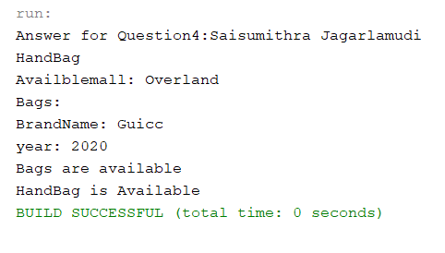

1. (10-Points) Design a class named **Person** and its two subclasses named **Student** and **Employee**. Make **Faculty** and **Staff** subclasses of **Employee**. A person has a name, address, phone number, and email address. A student has a grade and class status (Graduate). Define the status as a constant. An employee has an office, salary, and date hired. A faculty member has office hours and number of teaching subjects. A staff member has a title. Override the **toString** method in each class to display the class name and the person’s name.

Draw the UML diagram for the classes and implement them. Write a test program that creates a **Person**, **Student**, **Employee**, **Faculty**, and **Staff**, and invokes their **toString**() methods.

Note: All classes should have **toString()** Method.

Answer:

UML Diagram:

|  |
| --- |
| /*  * To change this license header, choose License Headers in Project Properties.  * To change this template file, choose Tools | Templates  * and open the template in the editor.  */  package Exam02_Q5;  /**  *  * @author Saisumithra Jagarlamudi  */  public class Person {  private String name;  private String address;  private String phoneNumber;  private String emailAddress;  public Person(String name, String address, String phoneNumber, String emailAddress) {  this.name = name;  this.address = address;  this.phoneNumber = phoneNumber;  this.emailAddress = emailAddress;  }    public String getName() {  return name;  }  public String getAddress() {  return address;  }  public String getPhoneNumber() {  return phoneNumber;  }  public String getEmailAddress() {  return emailAddress;  }  @Override  public String toString() {  return "Person Name: " + name ;  }  }  /*  * To change this license header, choose License Headers in Project Properties.  * To change this template file, choose Tools | Templates  * and open the template in the editor.  */  package Exam02_Q5;  /**  *  * @author Saisumithra Jagarlamudi  */  public class Employee extends Person {  private String office;  private double salary;  private String dateHired;  public Employee(String office, double salary, String dateHired, String name, String address, String phoneNumber, String emailAddress) {  super(name, address, phoneNumber, emailAddress);  this.office = office;  this.salary = salary;  this.dateHired = dateHired;  }  public String getOffice() {  return office;  }  public double getSalary() {  return salary;  }  public String getDateHired() {  return dateHired;  }  @Override  public String toString() {  return "Employee Name: "+super.getName();    }  }  /*  * To change this license header, choose License Headers in Project Properties.  * To change this template file, choose Tools | Templates  * and open the template in the editor.  */  package Exam02_Q5;  /**  *  * @author Saisumithra Jagarlamudi  */  public class Student extends Person{  private String grade;  private final String classStatus= "Graduate";  public Student(String grade, String name, String address, String phoneNumber, String emailAddress) {  super(name, address, phoneNumber, emailAddress);  this.grade = grade;  }  public String getGrade() {  return grade;  }  public String getclassStatus() {  return classStatus;  }  @Override  public String toString() {  return "Student Name: " +super.getName();  }  }      /*  * To change this license header, choose License Headers in Project Properties.  * To change this template file, choose Tools | Templates  * and open the template in the editor.  */  package Exam02_Q5;  /**  *  * @author Saisumithra Jagarlamudi  */  public class Faculty extends Employee {    private String officeHours;  private int numberofteachingsubjects;  public Faculty(String officeHours, int numberofTeachingHours, String office, double salary, String dateHired, String name, String address, String phoneNumber, String emailAddress) {  super(office, salary, dateHired, name, address, phoneNumber, emailAddress);  this.officeHours = officeHours;  this.numberofteachingsubjects = numberofTeachingHours;  }  public String getOfficeHours() {  return officeHours;  }  public int getNumberofteachingsubjects() {  return numberofteachingsubjects;  }  @Override  public String toString() {  return "Faculty Name: " +super.getName();  }  }    /*  * To change this license header, choose License Headers in Project Properties.  * To change this template file, choose Tools | Templates  * and open the template in the editor.  */  package Exam02_Q5;  /**  *  * @author Saisumithra Jagarlamudi  */  public class Staff extends Employee {    private String title;  public Staff(String title, String office, double salary, String dateHired, String name, String address, String phoneNumber, String emailAddress) {  super(office, salary, dateHired, name, address, phoneNumber, emailAddress);  this.title = title;  }  public String getTitle() {  return title;  }  @Override  public String toString() {  return "Staff Name: "+super.getName();  }  }  /*  * To change this license header, choose License Headers in Project Properties.  * To change this template file, choose Tools | Templates  * and open the template in the editor.  */  package Exam02_Q5;  /**  *  * @author Saisumithra Jagarlamudi  */  public class Driver {  /**  * @param args the command line arguments  */  public static void main(String[] args) {  // TODO code application logic here  System.out.println("Answer for Question 5: Saisumithra Jagarlamudi");  Person p = new Person("Sai", "1215 West,Apt:29","1234567898","Sumithra@gmail.com");  Employee E = new Employee("IBM",2000,"21-3-2019","Sumithra","Maryville","3446778787","Cbs@gmail.com");  Faculty F = new Faculty("2:00 to 3:20",3,"professor",5000,"3/4/2015","Jagarlamudi","nashville","8387883654","sj@gmail.com");  Staff s = new Staff("Admin","TCS",60000,"4/23/2018","Harish","Texas","7366553765","efg@gmail.com");  Student d = new Student("A","Varsha","Virginia","8373674673","Ammu@gmail.com");  System.out.println(p.toString());  System.out.println(E.toString());  System.out.println(d.toString());  System.out.println(F.toString());  System.out.println(s.toString());    }  } |

Output:

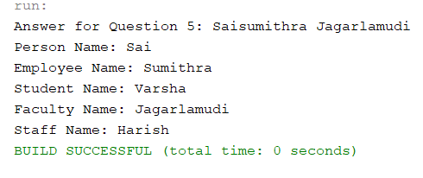

1. (10-Points) Design a new **Triangle** class that extends the abstract **GeometricObject** class. Draw the UML diagram for the classes **Triangle** and **GeometricObject** and then implement the **Triangle** class. Write a test program that prompts the user to enter three sides of the triangle, a color, and a Boolean value to indicate whether the triangle is filled. The program should create a **Triangle** object with these sides and set the color and filled properties using the input. The program should display the area, perimeter, color, and true or false to indicate whether it is filled or not. Provide screenshot of executable code with input and output.

Answer:

UML Diagram:

|  |
| --- |
| /*  * To change this license header, choose License Headers in Project Properties.  * To change this template file, choose Tools | Templates  * and open the template in the editor.  */  package Exam02_Q6;  /**  *  * @author Saisumithra Jagarlamudi  */  public abstract class GeometricObject {  private String color;  private boolean filled;  public GeometricObject(String color, boolean filled) {  this.color = color;  this.filled = filled;  }  public String getColor() {  return color;  }  public boolean isFilled() {  return filled;  }  public abstract double getArea();  public abstract double getPerimeter();  @Override  public String toString() {  return "Color: " + color + "\nFilled: " + filled ;  }  }  /*  * To change this license header, choose License Headers in Project Properties.  * To change this template file, choose Tools | Templates  * and open the template in the editor.  */  package Exam02_Q6;  import java.lang.*;  /**  *  * @author Saisumithra Jagarlamudi  */  public class Triangle extends GeometricObject {  private double a;  private double b;  private double c;  public Triangle(String color, boolean filled) {  super(color, filled);  }  public Triangle(double a, double b, double c, String color, boolean filled) {  super(color, filled);  this.a = a;  this.b = b;  this.c = c;  }  public double getA() {  return a;  }  public double getB() {  return b;  }  public double getC() {  return c;  }  public double getArea() {  double s = (a+b+c) / 2;  return Math.sqrt(s * (s - a) * (s - b) * (s - c));  }  public double getPerimeter() {  return a + b + c;  }  public String toString() {  return super.toString() + "\nArea:" + getArea() +  "\nPerimeter:" + getPerimeter();  }  }  /*  * To change this license header, choose License Headers in Project Properties.  * To change this template file, choose Tools | Templates  * and open the template in the editor.  */  package Exam02_Q6;  import java.util.Scanner;  /**  *  * @author Saisumithra Jagarlamudi  */  public class Driver {    public static void main(String[] args) {    Scanner input = new Scanner(System.in);    System.out.println("Answer For Question6: Saisumithra Jagarlamudi");  System.out.print("Enter a value of the triangle: ");  double a = input.nextDouble();  System.out.print("Enter b value of the triangle: ");  double b = input.nextDouble();  System.out.print("Enter c value of the triangle: ");  double c = input.nextDouble();  System.out.print("Enter a color: ");  String color = input.next();  System.out.print("Is the triangle filled (true / false)? ");  boolean filled = input.nextBoolean();    Triangle triangle = new Triangle(a, b, c, color, filled);  System.out.println(triangle);  }  } |

Output:

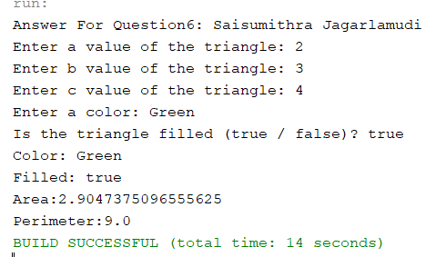

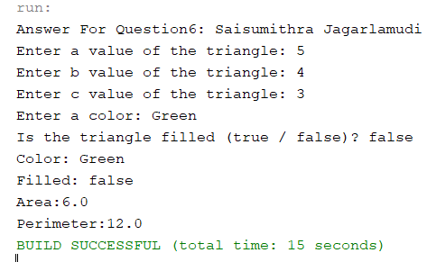

1. (10-Points) What is an Enum in Java? Explain and demonstrate with some examples. Provide executable code screenshots for examples.

Answer:

Enum: enum is a special class which contains constants. We use keyword enum.

Explanation: I have created a class enum with name BagsBrand and used names of brands as constants. And declared managername, phonenumber, city and pincode. Of bags. And created constructor, getter methods. Here I have use a method to display listofshowrooms where bags are available where it returns the cityname where the bags are available. In Driver class I have used enhanced for loop which will display enum class of BagBrands details.

|  |
| --- |
| /*  * To change this license header, choose License Headers in Project Properties.  * To change this template file, choose Tools | Templates  * and open the template in the editor.  */  package Exam02_Q7;  import java.util.ArrayList;  import java.util.List;  /**  *  * @author Saisumithra Jagarlamudi  */  public enum BagsBrand {  /**  *  */  GUCCI("ABC", 52436775, "Kansas", 3456),  /**  *  */  PRADA("CDA", 4095990, "Maryville", 1053),  /**  *  */  LOUISVUITTON( "FGH", 7655321, "Kansas", 54321);    private final String Managername;  private final long phonenumber;  private final String city;  private final long pincode;  private BagsBrand(String Managername, long phonenumber, String city, long pincode) {  this.Managername = Managername;  this.phonenumber = phonenumber;  this.city = city;  this.pincode = pincode;  }  public static BagsBrand getGUCCI() {  return GUCCI;  }  public static BagsBrand getPRADA() {  return PRADA;  }  public static BagsBrand getLOUISVUITTON() {  return LOUISVUITTON;  }  public String getManagername() {  return Managername;  }  public long getPhonenumber() {  return phonenumber;  }  public String getCity() {  return city;  }  public long getPincode() {  return pincode;  }  public static List<BagsBrand> getListofShowrooms(String cityname)  {  List<BagsBrand> hs = new ArrayList<>();  for(BagsBrand i :BagsBrand.values() )  {  if(i.getCity().equalsIgnoreCase(cityname)){  hs.add(i);  }  }  return hs;  }  }  /*  * To change this license header, choose License Headers in Project Properties.  * To change this template file, choose Tools | Templates  * and open the template in the editor.  */  package Exam02_Q7;  /**  *  * @author Saisumithra Jagarlamudi  */  public class Driver {  /**  * @param args the command line arguments  */  public static void main(String[] args) {  // TODO code application logic here  System.out.println("Answer for Question 7: Saisumithra Jagarlamudi\n");  for(BagsBrand hs : BagsBrand.values())  {  System.out.println(hs+ "\nBag Brand is:"+hs.toString()+"\n"+"Manager name: "+hs.getManagername() + "\n"+"PhonrNumber: "+hs.getPhonenumber()+"\n"+"pincode: "+hs.getPincode()+"\ncity: "+hs.getCity()+"\n");  }  System.out.println("*******************");  System.out.println("ListofBrandsinKAnsas"+BagsBrand.getListofShowrooms("kansas").toString());  }  } |

Output:

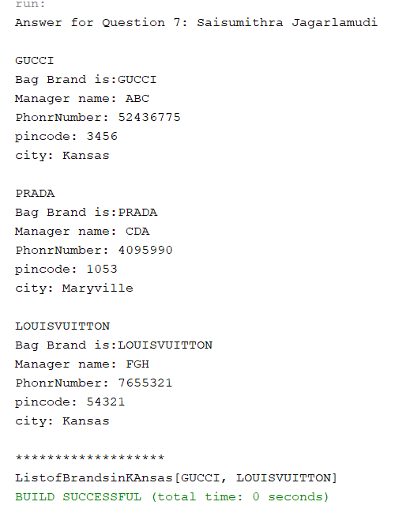

Example 2:

Explanation: Here I have created enum with Cars where BENZ, AUDI, BMW will be constants. Which defines the condition of Car.

|  |
| --- |
| /*  * To change this license header, choose License Headers in Project Properties.  * To change this template file, choose Tools | Templates  * and open the template in the editor.  */  package Exam02_Q7_2;  /**  *  * @author Saisumithra Jagarlamudi  */  public enum Cars {  BENZ("Excellent"),AUDI("Average"),BMW("Good");  private final String Model;  private Cars(String Model) {  this.Model = Model;  }  public String getModel() {  return Model;  }  }      /*  * To change this license header, choose License Headers in Project Properties.  * To change this template file, choose Tools | Templates  * and open the template in the editor.  */  package Exam02_Q7_2;  /**  *  * @author Saisumithra Jagarlamudi  */  public class Driver {  /**  * @param args the command line arguments  */  public static void main(String[] args) {  // TODO code application logic here  System.out.println("Answer for Question 7:Saisumithra");  System.out.println("Model of Car: "+Cars.AUDI.getModel());  }  } |

Output:

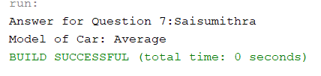

1. (10-points) Define the term abstract class in java? Explain and demonstrate with some examples. Provide executable code screenshots for examples.

Answer:

Abstract Class : In Abstract class we use keyword as abstract. It contains abstract methods

With out body.

Explanation: Here I have created abstract class for Bags. Here I have given abstract method as getvolume and getprice of bag based on height, width, depth, costpercubicmeter.Where Bags extends Travelbag and Backpackbag. In TravelBag I have given methods to find the volume and price of bag. Where BackPack extends Bags here also we declare method volume and price of bag where I have given fixed value for volume. AmericanTourist extends BackPack.

In driver class I have created an objects for TravelBag and AmericanTourist bag classes. With objects created I have calculated the price, volume, number of wheels, is lock available for travelbag and brand name and volume for Americantourist bag.

|  |
| --- |
| /*  * To change this license header, choose License Headers in Project Properties.  * To change this template file, choose Tools | Templates  * and open the template in the editor.  */  package Exam02_Q8;  /**  *  * @author Saisumithra Jagarlamudi  */  public abstract class Bags {  private double height;  private double width;  private double depth;  private double costpercubicmeter;  private String brandname;    public Bags(double height, double width, double depth, double costpercubicmeter, String brandname) {  this.height = height;  this.width = width;  this.depth = depth;  this.costpercubicmeter = costpercubicmeter;  this.brandname = brandname;  }    public abstract double getvolume();  public abstract double getprice();  public double getHeight() {  return height;  }  public double getWidth() {  return width;  }  public double getDepth() {  return depth;  }  public double getCostpercubicmeter() {  return costpercubicmeter;  }  public String getBrandname() {  return brandname;  }  }  /*  * To change this license header, choose License Headers in Project Properties.  * To change this template file, choose Tools | Templates  * and open the template in the editor.  */  package Exam02_Q8;  /**  *  * @author Saisumithra Jagarlamudi  */  public class TravelBag extends Bags  {  private boolean hasnumberlock;  private int wheels;  public TravelBag(boolean hasnumberlock, int wheels, double height, double width, double depth, double costpercubicmeter, String brandname) {  super(height, width, depth, costpercubicmeter, brandname);  this.hasnumberlock = hasnumberlock;  this.wheels = wheels;  }  public boolean isHasnumberlock() {  return hasnumberlock;  }  public int getWheels() {  return wheels;  }  @Override  public double getvolume() {  return getHeight()*getWidth()*getDepth();  }  @Override  public double getprice() {  return getvolume()*getCostpercubicmeter();  }  }    /*  * To change this license header, choose License Headers in Project Properties.  * To change this template file, choose Tools | Templates  * and open the template in the editor.  */  package Exam02_Q8;  /**  *  * @author Saisumithra Jagarlamudi  */  public class BackPack extends Bags {  public BackPack(double height, double width, double depth, double costpercubicmeter, String brandname) {  super(height, width, depth, costpercubicmeter, brandname);  }  @Override  public double getvolume() {  return 21;  }  @Override  public double getprice() {  return getvolume()*getCostpercubicmeter() ;  }      }  /*  * To change this license header, choose License Headers in Project Properties.  * To change this template file, choose Tools | Templates  * and open the template in the editor.  */  package Exam02_Q8;  /**  *  * @author Saisumithra Jagarlamudi  */  public class AmericanTourist extends BackPack {  public AmericanTourist(double height, double width, double depth, double costpercubicmeter)  {  super(height,width,depth,costpercubicmeter,"WildCraft");  }    }  /*  * To change this license header, choose License Headers in Project Properties.  * To change this template file, choose Tools | Templates  * and open the template in the editor.  */  package Exam02_Q8;  /**  *  * @author Saisumithra Jagarlamudi  */  public class Driver {  /**  * @param args the command line arguments  */  public static void main(String[] args) {  // TODO code application logic here  System.out.println("Answer For Question8: Saisumithra Jagarlamudi");  AmericanTourist sh = new AmericanTourist(12,34,54,1);  sh.getprice();  sh.getBrandname();  sh.getvolume();    TravelBag hs = new TravelBag(true,4,1,2,3,4,"totbag");  hs.getvolume();  hs.isHasnumberlock();  hs.getWheels();  hs.getprice();    System.out.println("Number of Wheels for Travel bag: "+hs.getWheels());  System.out.println("Price of TravelBag:"+hs.getprice());  System.out.println( "Volume of Travelbag:"+hs.getvolume());  System.out.println("Is Number Lock available:"+hs.isHasnumberlock());  System.out.println("*****************");  System.out.println("Brand name of AmericanTourist:"+sh.getBrandname());  System.out.println("Volume of AmericanTourist:"+sh.getvolume());    }    } |

Output:

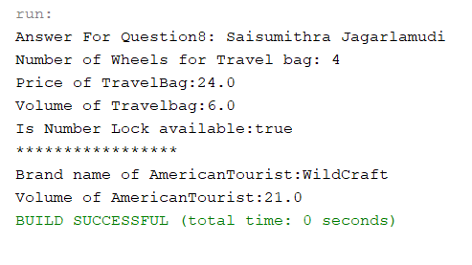

Example 2:

Explanation:

In class Cars I have created an abstract methods of year and model of car. Created another class as Benz which extends Cars. Where I specified Year and model methods in Benz class and in driver I created an object and called methods.

|  |
| --- |
| /*  * To change this license header, choose License Headers in Project Properties.  * To change this template file, choose Tools | Templates  * and open the template in the editor.  */  package Exam02_Q8_2;  /**  *  * @author Saisumithra Jagarlamudi  */  public abstract class Cars {    public abstract void year();  public abstract void model();    }      /*  * To change this license header, choose License Headers in Project Properties.  * To change this template file, choose Tools | Templates  * and open the template in the editor.  */  package Exam02_Q8_2;  /**  *  * @author Saisumithra Jagarlamudi  */  public class Benz extends Cars{    public void model()  {    System.out.println("AAA");  }    @Override  public void year() {  System.out.println("2020");  }  }  /*  * To change this license header, choose License Headers in Project Properties.  * To change this template file, choose Tools | Templates  * and open the template in the editor.  */  package Exam02_Q8_2;  /**  *  * @author Saisumithra Jagarlamudi  */  public class Driver {  /**  * @param args the command line arguments  */  public static void main(String[] args) {  // TODO code application logic here  System.out.println("Answer for Question8:Saisumithra Jagarlamudi");  Cars o = new Benz();  o.model();  o.year();  }    } |

Output:

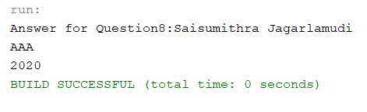

1. (10-points) Define the term interface in java? Explain and demonstrate with some examples. Provide executable code screenshots for examples.

Answer:

Interface:

Interfaces defines methods. To access the interface methods, the interface must be implemented by another class with implements keyword.

Explanation:

I have created a Bags interface class. It specifies the quality, size of bags. And created a method to find the volume. Where Bags implements HandBags and TravelBags. In driver I have created an object to find the Quality, size, volume, material type of bags.

Example 1:

|  |
| --- |
| /*  * To change this license header, choose License Headers in Project Properties.  * To change this template file, choose Tools | Templates  * and open the template in the editor.  */  package Exam02_Q9;  /**  *  * @author Saisumithra Jagarlamudi  */  public interface Bags {  public enum Quality {  old,  moderate,  latest;  }  public enum Size {  large,small,medium;  }  public String Quality();  public String Size();  public double getVolume();  }  /*  * To change this license header, choose License Headers in Project Properties.  * To change this template file, choose Tools | Templates  * and open the template in the editor.  */  package Exam02_Q9;  import static Exam02_Q9.Bags.Quality.latest;  import static Exam02_Q9.Bags.Quality.moderate;  import static Exam02_Q9.Bags.Quality.old;  import static Exam02_Q9.Bags.Size.small;  /**  *  * @author Saisumithra Jagarlamudi  */  public class HandBag implements Bags{  private double height;  private double width;  private double depth;  private String brandname;  private double price;  private int manufactureyear;  private String material;  public HandBag(double height, double width, double depth, String brandname, double price, int manufactureyear, String material) {  this.height = height;  this.width = width;  this.depth = depth;  this.brandname = brandname;  this.price = price;  this.manufactureyear = manufactureyear;  this.material = material;  }  public double getHeight() {  return height;  }  public double getWidth() {  return width;  }  public double getDepth() {  return depth;  }  public String getBrandname() {  return brandname;  }  public double getPrice() {  return price;  }  public int getManufactureyear() {  return manufactureyear;  }  public String getMaterial() {  return material;  }    @Override  public String Quality() {  if(material.equalsIgnoreCase("Leather"))  {  if(manufactureyear > 2018)  {  return latest.toString();  }else if(manufactureyear > 2012)  {  return moderate.toString();  }  else  return old.toString();  }else  {  if(manufactureyear > 2020)  {  return latest.toString();  }else if(manufactureyear > 2015)  {  return moderate.toString();  }  else  return old.toString();  }  }  @Override  public String Size() {  return small.toString();  }  @Override  public double getVolume() {  return height*width*depth;  }      }  /*  * To change this license header, choose License Headers in Project Properties.  * To change this template file, choose Tools | Templates  * and open the template in the editor.  */  package Exam02_Q9;  import static Exam02_Q9.Bags.Quality.latest;  import static Exam02_Q9.Bags.Quality.moderate;  import static Exam02_Q9.Bags.Quality.old;  import static Exam02_Q9.Bags.Size.large;  import static Exam02_Q9.Bags.Size.medium;  import static Exam02_Q9.Bags.Size.small;  /**  *  * @author Saisumithra Jagarlamudi  */  public class TravelBag implements Bags {  private double height;  private double width;  private double depth;  private String brandname;  private double price;  private int manufactureyear;  public TravelBag(double height, double width, double depth, String brandname, double price, int manufactureyear) {  this.height = height;  this.width = width;  this.depth = depth;  this.brandname = brandname;  this.price = price;  this.manufactureyear = manufactureyear;  }  public double getHeight() {  return height;  }  public double getWidth() {  return width;  }  public double getDepth() {  return depth;  }  public String getBrandname() {  return brandname;  }  public double getPrice() {  return price;  }  public int getManufactureyear() {  return manufactureyear;  }  @Override  public String Quality() {  if(manufactureyear > 2020)  {  return latest.toString();  }else if(manufactureyear > 2015)  {  return moderate.toString();  }  else  return old.toString();  }  @Override  public String Size() {  double Volume = getVolume();  if(Volume>10)  {  return large.toString();  }  else if(Volume>5)  {  return medium.toString();  }  else  return small.toString();  }  @Override  public double getVolume() {  return height*depth*width;  }      }  /*  * To change this license header, choose License Headers in Project Properties.  * To change this template file, choose Tools | Templates  * and open the template in the editor.  */  package Exam02_Q9;  /**  *  * @author Saisumithra Jagarlamudi  */  public class Driver {  /**  * @param args the command line arguments  */  public static void main(String[] args) {  // TODO code application logic here  System.out.println("Answer For Question9: Saisumithra Jagarlamudi");  TravelBag hs = new TravelBag(1,2,3,"bs",23,2020);    System.out.println("Quality of TravelBag:"+hs.Quality());  System.out.println("Size of the Travelbag:"+hs.Size());  System.out.println("Volume of the Travelbag:"+hs.getVolume());    HandBag sh = new HandBag(1,3,4,"gs",56,2015,"leather");    System.out.println("Quality of HandBag:"+sh.Quality());  System.out.println("Size of HandBag:"+sh.Size());  System.out.println("Volume of HandBag:"+sh.getVolume());  System.out.println("Material of HandBag:"+sh.getMaterial());    }    } |

Output:

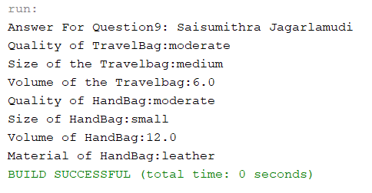

Example 2:

Explanation:

I have created a interface of Cars class which implements Benz,BMW. In driver created an object to find the model, year, address of Cars.

|  |
| --- |
| /*  * To change this license header, choose License Headers in Project Properties.  * To change this template file, choose Tools | Templates  * and open the template in the editor.  */  package Exam02_Q9_2;  /**  *  * @author Saisumithra Jagarlamudi  */  public interface Cars {    public void Year();  public void model();    }    /*  * To change this license header, choose License Headers in Project Properties.  * To change this template file, choose Tools | Templates  * and open the template in the editor.  */  package Exam02_Q9_2;  /**  *  * @author Saisumithra Jagarlamudi  */  public class Benz implements Cars{  private static final String year="2020";  private static final String model="AAA";      public void model()  {  System.out.println("Benz Car manufactured year:"+model);  }  @Override  public void Year() {  System.out.println("Benz Car manufactured year:"+year);    }  }  /*  * To change this license header, choose License Headers in Project Properties.  * To change this template file, choose Tools | Templates  * and open the template in the editor.  */  package Exam02_Q9_2;  /**  *  * @author Saisumithra Jagarlamudi  */  public class BMW implements Cars {  private static final String year="2021";  private static final String model="AA";  private static final String address="Nashville";      public void model()  {  System.out.println("BMW Car manufactured model:"+model);  }  @Override  public void Year() {  System.out.println("BMW Car manufactured year:"+year);  }  public void address()  {  System.out.println("BMW Car manufactured address:"+address);    }  }  /*  * To change this license header, choose License Headers in Project Properties.  * To change this template file, choose Tools | Templates  * and open the template in the editor.  */  package Exam02_Q9_2;  /**  *  * @author Saisumithra Jagarlamudi  */  public class Driver {  /**  * @param args the command line arguments  */  public static void main(String[] args) {  // TODO code application logic here  System.out.println("Answer for Question 9:Saisumithra Jagarlamudi");  Benz benz = new Benz();  BMW bmw = new BMW();  benz.model();  benz.Year();  bmw.Year();  bmw.model();  bmw.address();  }  } |

Output:

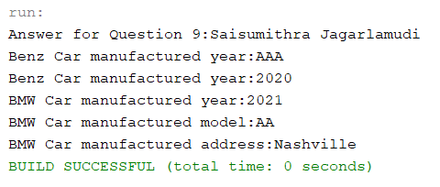

1. (15-Points) Consider the following code for three classes One, Two, and Three. (A UML diagram is included for your convenience.)

|  |
| --- |
| public class One {  private int a;  public One(int in){  a = in;  }  public int guess (int x){  System.out.println("One guess " + x);  return a + x;  }    public int apply (int x){  System.out.println("One guess " + x);  return guess(x + 3);  }  } // end class One  public class Two extends One {  public Two(){  super(11);  }  public int guess(int x){  System.out.println("Two guess " + x);  return super.guess(x)+10;  }    } // end class Two  public class Three extends Two {  public int apply(int x){  System.out.println("Three apply " + x);  return -10;  }  } // end class Three |

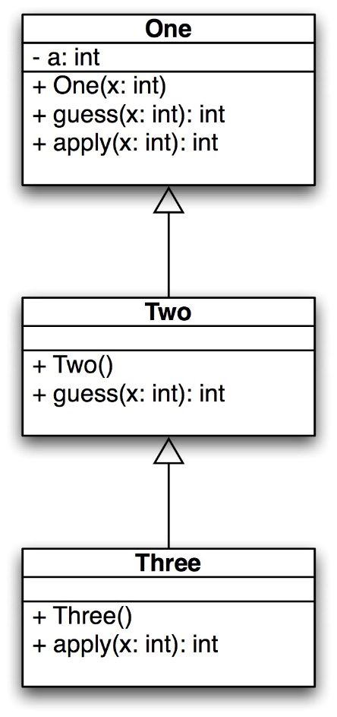

What is the output of the following code? Explain it.

|  |
| --- |
| public static void main(String[] args) {  One hippo = new Three();  System.out.println(hippo.guess(4));  System.out.println(hippo.apply(12));  One lion = new One(-1);  System.out.println(lion.guess(5));  System.out.println(lion.apply(6));  } // end |

Output:

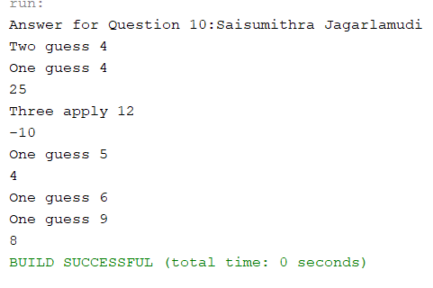

Explanation:

One hippo = new Three();

One class has object hippo

First it checks constructor from class Three.

Class Three has no constructor, it checks for super class where it calls Two class and it has constructor and again super(11) it goes to class one constructor where in = 11 will assign.

System.out.println(hippo.guess(4));

It goes to method which is guess in class three and class three does not contain guess method it checks in super class which is Two class it contains guess method then it prints

Two guess 4

returns super.guess(x)+10

it goes to class One

one guess 4

return a+x;

returns 15;

return super(x)+10;

which returns 25

System.out.println(hippo.apply(12));

In class three we have method apply so it goes in class Three so it prints

Three apply 12

And it returns -10 so it prints

-10

One lion = new One(-1);

It goes to constructor in class One and will assign the value of a = -1

System.out.println(lion.guess(5));

It goes for method guess in class One because lion object was created for class One and goes to One class and prints

One guess 5

return (a+x) a= -1 and x= 5

so it prints 4

System.out.println(lion.apply(6));

It checks in apply method of class One because lion is object for class One. And it prints

One guess 6

returns guess (x+3):means it goes to guess method in class One and prints

One guess 9

return (a+x) where a=-1 as they had specified argument as -1

returns (-1+9)

8

Output:

Two guess 4

One guess 4

25

Three apply 12

-10

One guess 5

4

One guess 6

One guess 9

8

Github Link: https://github.com/Saisumithra/Jagarlamudi_Takehomeexam_02.git